THE PRESIDENT’S OFFICE
REGIONAL ADMINISTRATION AND LOCAL GOVERNMENT
FORM TWO JOINT EXAMINATION FOR GOVERNMENT SCHOOLS – JEGOS
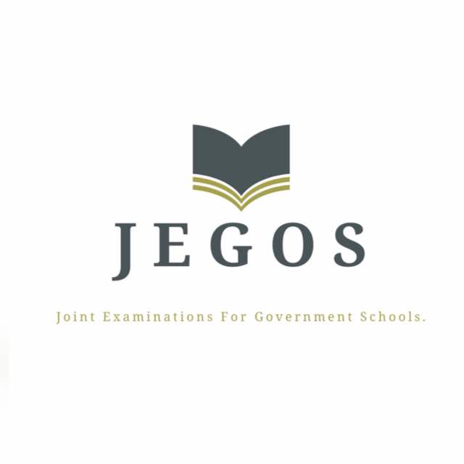

PRE-MOCK EXAMINATION
ENGLISH FORM TWO
MARKING SCHEME 2024

SECTION A (15 Marks)
QUESTION 1 (@1mark =10)
I | ii | iii | iv | v | vi | vii | viii | ix | x
D | A | D | B | A | B | C | B | D | E

QUESTION 2 (@ 1 mark = 5)
I | Ii | iii | iv | v
E | F | A | B | D

SECTION B (70 Marks)
QUESTION 3
- Two houses have been built by John in a very short time
- The guest of honour had no sooner stood up than the musicians sang
- “What is your name and what do you what?” he asked me.
- Notwithstanding his richness, he is not happy with this life @2marks
- They are going to wake up early

QUESTION 4
- If the bus had left early, you would have reached there on time
- If the war continued, the price would increase.
- If our team is beaten in the quarter final, the couch will be terminated
- In case he had won the race, he would have received a lot of money
- Had a young washed his hands, he would have eaten with elders @2marks

QUESTION 5
- The police asked me what my name was.
- The clerk wanted to know how old I was.
- The judge ordered me to sit there. @2marks
- The policeman asked me why I stole the money.
- The judge asked if I was a thief.

QUESTION 6
- She cooks food everyday.
- The sun rises in the east and sets in the west.
- He passes to ball to Aziz Ki. 2@marks
- He arrives here tomorrow from London.
- Nyerere says “Tanzania is our mother country”

QUESTION 7 (@ 2 Marks)
(i) Can I go out?
(ii) I have eaten
(iii) I don’t have the food
(iv) It might rain
(v) Do you know him? Yes I do.

QUESTION 8
- Adjective (my, our, his, your, its, their, her)
- Our country is beautiful
- Verb (possess, own, belong, have)
- The pen belongs to kambuga
- I possess two schools
- She owns a shop
- I have one goat
- Pronoun (ours, mine, its, his, yours, theirs, hers)
- Whose car is that? It is mine
- Don’t use my pencil you must buy yours @2marks
- Preposition (of, with, for)
- Jack is the wife of Mosses
- The man with two houses comes from Simiyu
- The present for my mother was stolen
- Noun
- Jerome’s car is black
- Miss Nyandika is preparing student’s notes

QUESTION 9 (@ 2 Marks)
- Always he tells the truth.
- He studies hard often.
- She is always crying at night
- I don’t always trust you
- He always used to smoke ten cigarettes a day.

SECTION C (15 Marks)
QUESTION 10
A candidate should identify three themes from each class reader and show their relevance to our societies.
Introduction 2marks
Main body @2marks=12
Conclusion 1mark

